Ερώτημα 1

Κώδικας:

LIBRARY ieee ;
USE ieee.std_logic_1164.all;

entity latch is port (
D : in bit;
EN : in bit;
Q : out bit);
end latch;

ARCHITECTURE dataflow OF latch IS
BEGIN
process (d, en) begin
if (en = '1') then
q <= d;
end if;
end process;
END dataflow;

Wave
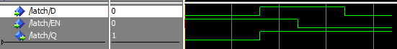

Κώδικας TestBench:

entity latchtb is
end latchtb;

architecture tb of latchtb is
signal D1, EN1, Q1: bit;
component latch port (D, EN: in bit; Q: out bit);
end component;
begin
M1: latch PORT MAP (D=>D1, EN=>EN1, Q=>Q1);
process
begin
EN1 <= '1'; wait for 130 ns;
EN1 <= '0'; wait for 270 ns;
EN1 <= '1'; wait for 130 ns;
EN1 <= '0'; wait for 270 ns;
EN1 <= '1'; wait for 130 ns;
EN1 <= '0'; wait for 270 ns;
end process;

process
begin
D1 <= '1'; wait for 270 ns;
D1 <= '1'; wait for 310 ns;
D1 <= '1'; wait for 230 ns;
D1 <= '1'; wait for 170 ns;
D1 <= '1'; wait for 90 ns;
D1 <= '1'; wait for 120 ns;
end process;

end tb;

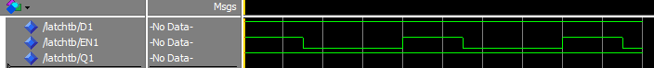
Wave

Ερώτημα 2

Κώδικας:
LIBRARY ieee ;
USE ieee.std_logic_1164.all;

entity flipflop is port (
D : in bit;
CLK : in bit;
Q : out bit);
end flipflop;

ARCHITECTURE dataflow OF flipflop IS
BEGIN
process(d, clk) begin
if (clk 'event and clk = '1') then
q <= d;
end if;
end process;
end dataflow;

Wave

Ερώτημα 3

Κώδικας:
LIBRARY ieee ;
USE ieee.std_logic_1164.all;

entity flipflop is port (
D : in bit;
CLK : in bit;
Rstn: in bit;
Q : out bit);
end flipflop;

ARCHITECTURE dataflow OF flipflop IS
BEGIN
process(cld, rstn) begin
if (rstn = '0') then
q <= '0';
elsif (clk 'event and clk = '1') then
q <= d;
end if;
end process;
end dataflow;

Wave

